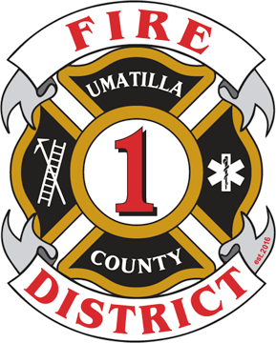Umatilla County Fire District #1

# 320 S. 1st Street

**Hermiston, OR 97838**

**541-567-8822 Bus | ucfd1.com**

**541-564-6463 Fax |** [**fir**](mailto:fire.district@ucfd1.com)[**e.district@ucfd1.com**](mailto:e.district@ucfd1.com)

Dear Interested Community Member:

We are excited that you are interested in serving on the Umatilla County Fire District #1 Board of Directors. We hope that this information packet answers all your questions concerning the open position.

Within this packet you will find information about special districts, fire districts specifically, what it means to be a board member, and how to serve on our board.

**Next Steps**

* Review this packet
* Contact Chief Stanton at [sstanton@ucfd1.com](mailto:sstanton@ucfd1.com) to submit an application by June 7, 2024 by 5 p.m.to be considered to fill the vacancy.

Thank you for your interest in serving on our board! If you have any questions, please don’t hesitate to contact Scott Stanton, Fire Chief, at sstanton@ucfd1.com and/or 541-567-8822.

Sincerely,

Ric Sherman

Umatilla County Fire District #1

Board President